Flexible Database Connection

- Under Restaurants.Infrastructure, we need to create a new folder name Extensions
- Then, create the class library name ServiceCollectionExtensions.cs
- Change the class to public static class
- Setup the file like below:
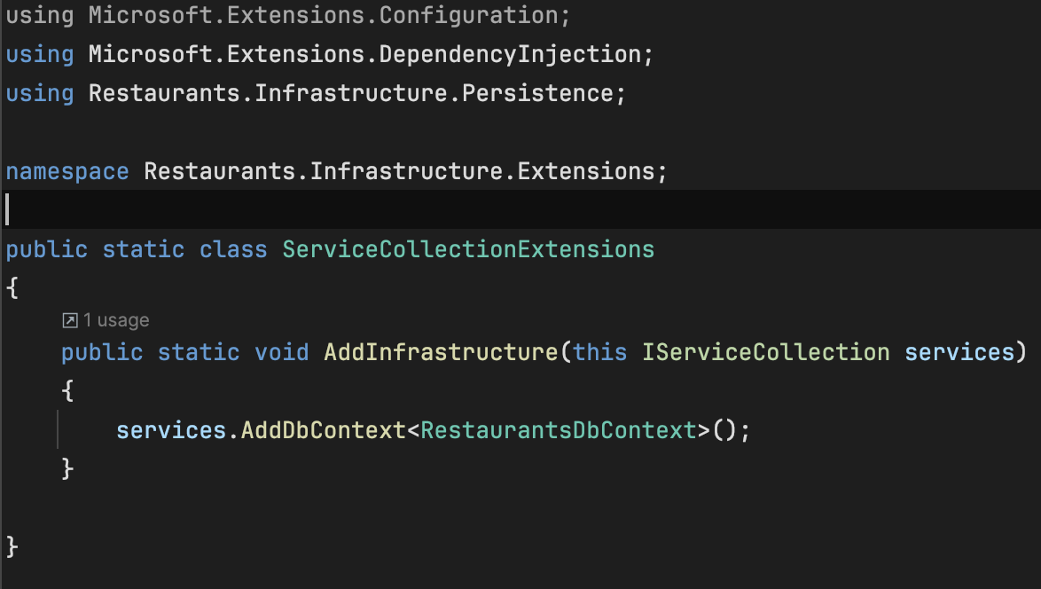

- Open the program.cs file under Restaurants.Api and create serviceBuilder for AddInfrastructure
- Must include using Restaurants.Infrastructure.Extensions;

- Setup the file like below:
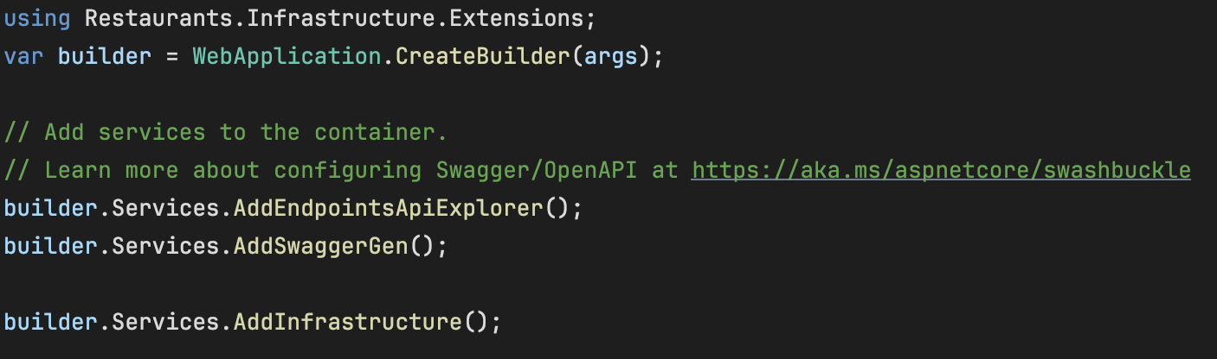

Avoid Hardcoding the Connection String
- Open the appsettings.Development.json in Restaurants.Api
- Create our connection string there and name it RestaurantsDbConn
- Code as below:
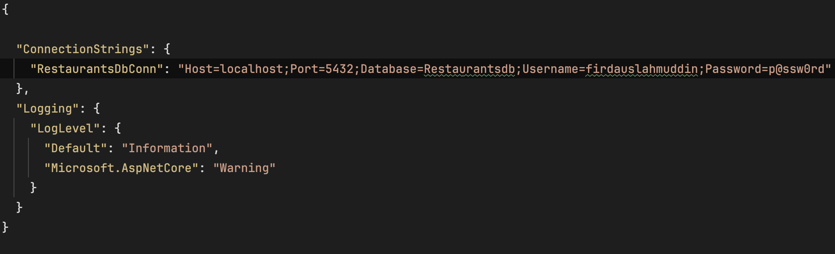
- Make sure to remove the connection string in the RestaurantsDbContext.cs
- Then we need to pass this connection so that our ServiceCollectionExtensions.cs can read it
- Modify our RestaurantsDbContext.cs
  - Remove OnConfiguring method
  - Change our primary constructor to insert DbContextOptions<RestaurantsDbContext>
  - The new RestaurantsDbContext are as below:
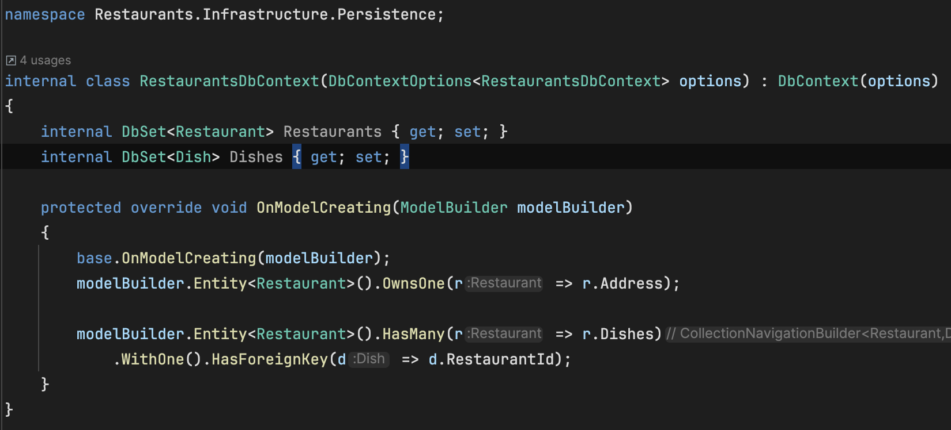
- Open Program.cs file to edit:
  - Create builder.Configuration.GetConnectionString
  - Make sure before var app = builder.Build(); REALLY IMPORTANT
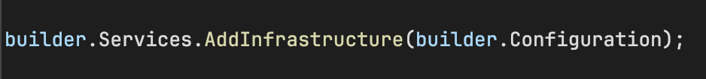
- Open ServiceCollectionExtensions.cs again to edit:
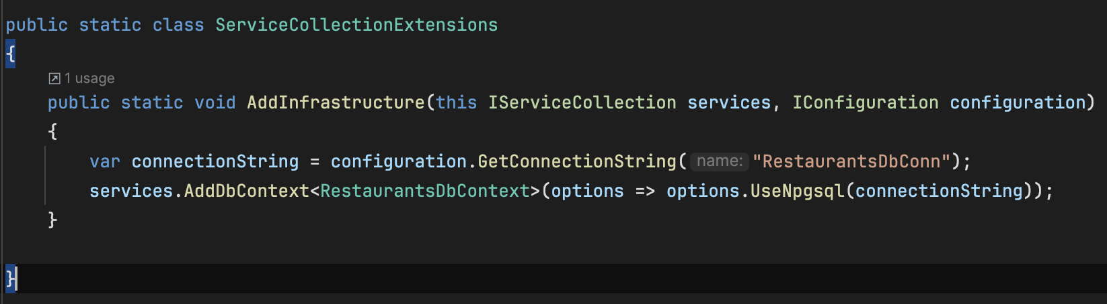
- Delete the database again to test and run:
  - dotnet ef database update -p ./Restaurants.Infrastructure.csproj -s ../Restaurants.Api/Restaurants.Api.csproj

